ROLE OF FLAVOURS in VAPING

Traditional tobacco control practitioners are inclined to say that banning tobacco flavours was the right thing to do, so banning vape flavours must also be the right thing to do. This lazy notion is totally wrong. No-one should ever use tobacco, so banning flavours to make tobacco less appealing is logical.
A more nuanced approach is required for vaping. The goal should be to provide a pleasant and palatable alternative for smokers, to encourage them to switch to vaping, while discouraging teens from vaping recreationally. (1).

The standard arguments for a flavour ban, for example from Health Canada, are:
Too many youths are vaping and this is dangerous for them.
Flavours are the main reason teen vape.
If flavours are not available, teens will not vape.
Tobacco-flavoured vape is adequate for smokers wanting to quit by vaping.
Therefore, a flavour ban will reduce teen vaping while still allowing smokers a way to quit (2).

Each of these statements is untrue (3).

YOUTH VAPING RATES
The 2020 Canadian Tobacco and Nicotine Survey (CTNS) data shows that vaping by 15-19 year-olds declined slightly from 15.1% to 14.4% the previous year. However, this includes everyone who has vaped even if only once at a party, in the previous month. Only 2% of teens are vaping daily, and half of those are smokers using vape as a safer alternative to smoking (4).

ROLE OF FLAVOURS IN INITIATION OF VAPING
This is a difficult issue. Why do humans do anything? Why do I drive a Honda, own a pet schnoodle, eat Royal Gala apples, drink beer, and live in Toronto? If I was presented with a multiple-choice questionnaire with a limited range of options, would I say “Because it is fun”, “Because my friends do”, “Because it gets good reviews”, “Because it is readily available” or “Because of the flavour”? Even if the questionnaire was well designed and I was trying hard to be honest, do I actually know why I made these choices? Many factors, both conscious and unconscious, go into human decision making.

People who do not vape think that the there are far too many vape flavours, but if vaping Strawberry Peach Lemonade flavour helps someone stop smoking why is this an issue? I know an adult vaper who uses Fruit Loops and another likes Earl Grey Tea flavour. If a flavour takes you to your happy place and keeps you away from tobacco, it is doing good. Consumers expect choices, which is why Baskin-Robbins has introduced more than 1,300 flavours of ice cream (Wikipedia)and why there are 1,128 craft breweries producing 9,868 different beers in Canada (https://justbeerapp.com/guides). Teens probably eat ice cream and drink beer because they like the flavours, but no one is suggesting a flavour ban as a cure for obesity or alcoholism.
Most people who vape use flavoured vape liquid, just as almost no-one would eat flavourless food or drink flavourless alcohol. The flavour is an essential part of the experience. Even medicines are frequently made sweet and given artificial flavours to make them more palatable. Health Canada says that 99% of vapers use flavoured products (2), and the FDA states that 84.7% of current youth vapers use flavored e-cigarettes (5). This is because vape is intended to be consumed as a flavoured product. It does not mean that removing flavours would prevent teens from vaping. As an analogy, most drivers have coloured cars, but if only metal-coloured cars were permitted, people would still drive.
There have been many surveys which ask why teens vape. Flavours are usually not the first answer, but feature in the top five.
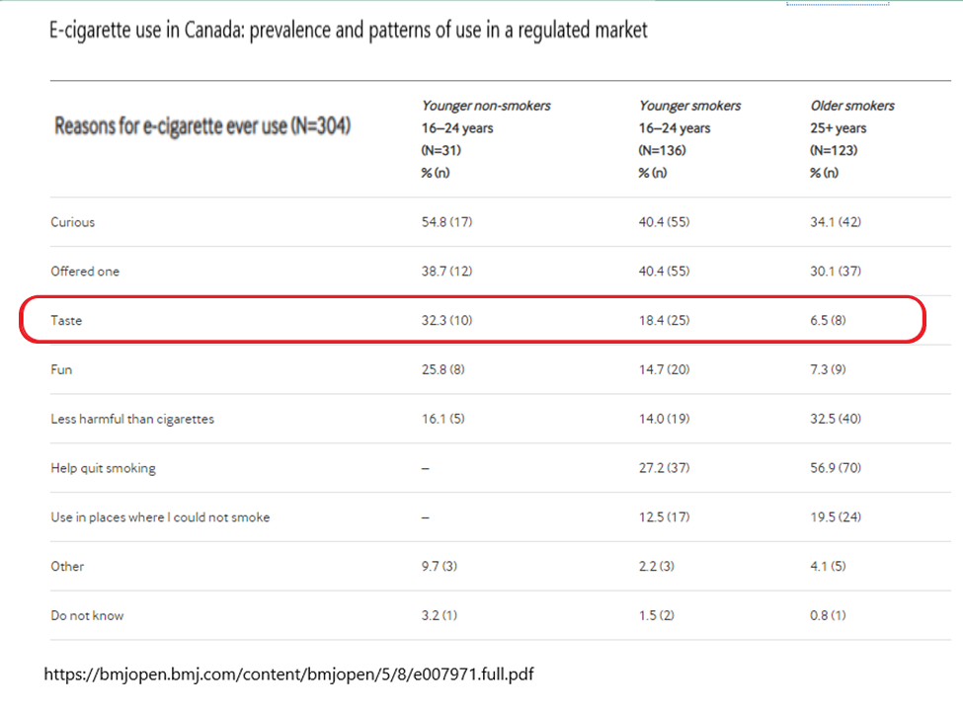
In Canada, 21% of 16–24-year-old vapers say that they vape for the flavours. smokers (25%) than for non-smokers (10%) rated taste as important. It was the third most popular choice after “Curious” and “Offered one” (6). In another study, of Canadians aged 15-19, the most commonly reported reasons for vaping were: because they enjoyed it (27%); because they wanted to try (26%); and to reduce stress (23%)” (4).
Health Canada quoted a study in which Canadians aged aged 16–19 who had vaped in the past 30 days were asked for their top five reasons why they vaped. 50% said “for fun/I like it”. 40% said “for the flavour”, 39% “curiosity/to try something new”, 24% “for the nicotine” and 35% “to deal with stress or anxiety” (4). Another way of looking at this data is that 60% of the respondents did NOT put “flavours” in their top five choices.
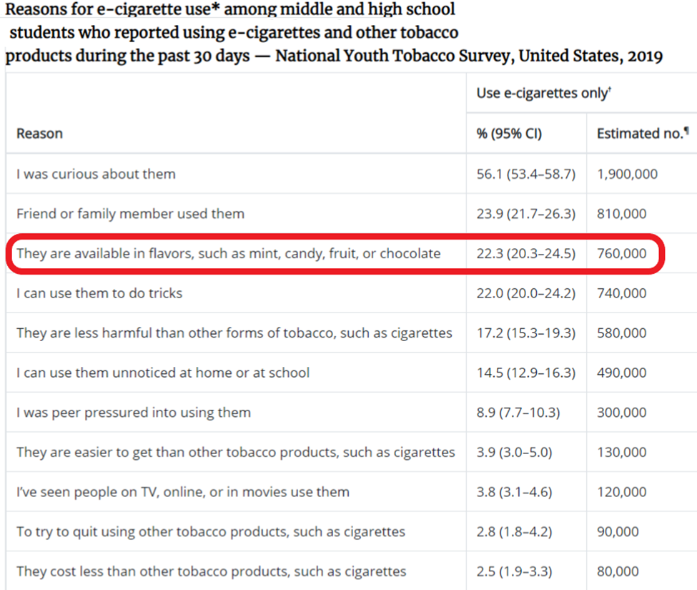

Among middle and high school students in the USA who ever tried using e-cigarettes, the most common reasons for e-cigarette use were: “I was curious about them” (55.3%); “friend or family member used them” (30.8%); “they are available in flavors, such as mint, candy, fruit or chocolate” (22.4%); and “I can use them to do tricks” (21.2%) (7).
In the UK, Action on Smoking and Health (ASH) asked 11 – 18 year-olds who had ever used an e-cigarette what reason best described why they use or used an e-cigarette. The most frequent reason was “Just to give it a try” (49.3%). The next most frequent response was “other people use them so I join in” 16.7%). Flavours came in third with just 13.9% of the vote. The least common reasons given for e-cigarette use were: “I am addicted to them” (0.6%); “They are cheaper than smoking” (0.8%); “They are easier to get hold of than tobacco cigarettes” (1.1%); and “I think they look cool” (1.2%) (8).
Given the many reasons why teens vape, it is illogical to assume that banning flavours would deter them from vaping.

WHAT FLAVOURS ARE MOST POPULAR?
In the early days of vaping, people assumed that smokers wanting to switch to vaping would prefer to use tobacco-flavoured vape to mimic the smoking experience. However, it has become apparent that they do not want to be reminded of the taste and smell of tobacco. “Tobacco and menthol flavors, the two most popular flavors for initiating e-cigarette use prior to 2013, now rank as the 5th and 6th most popular currently used e-cigarette flavors, respectively” (9).
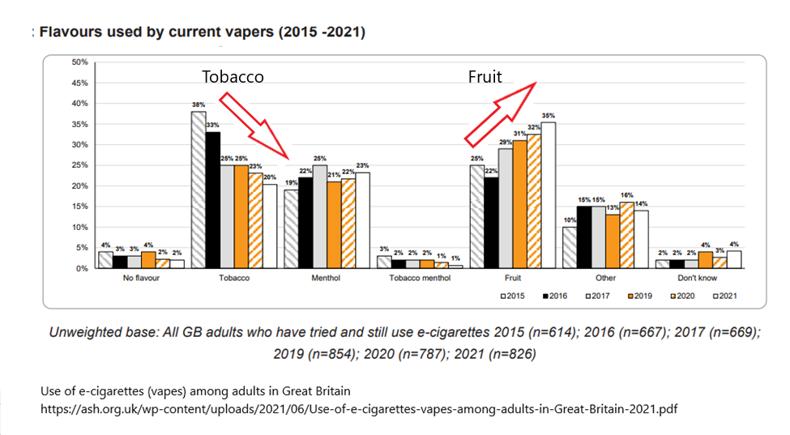
Vape does not contain tobacco, so to make tobacco-flavoured vape, artificial flavours and sweeteners are used. Anecdotally, smokers report that tobacco flavours are not very realistic, and in particular do not replicate the sensation of opening a fresh new pack of cigarettes.
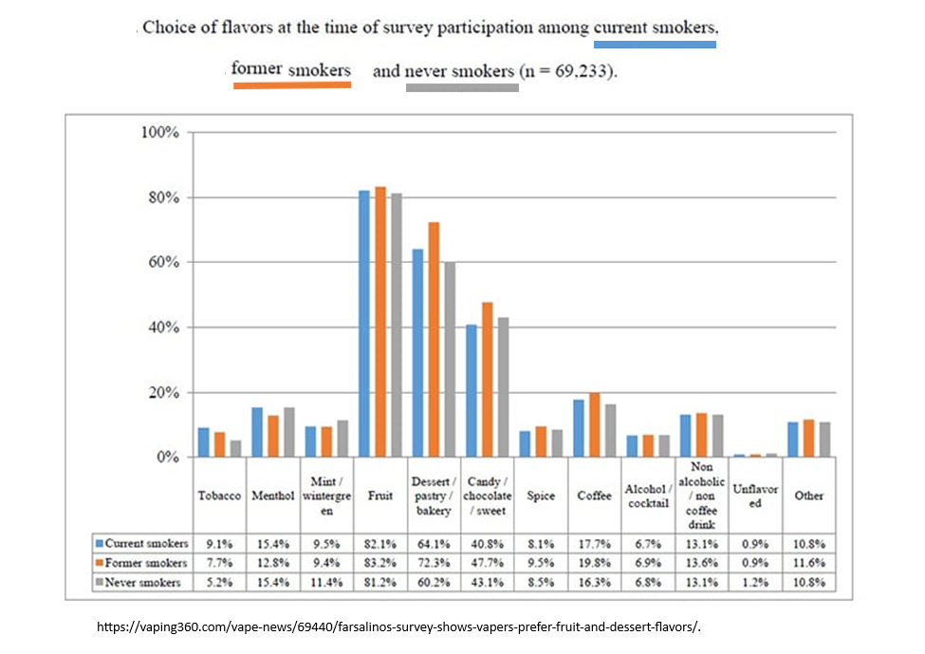
There is little difference between the preference of smokers and recreational vapers (10). It would be convenient if there were some flavours which were attractive to smokers but not to non-smoking teens, but this does not seem to be the case.

ROLE OF FLAVOURS FOR ADULT SMOKING CESSATION
Vaping is an effective way for adult smokers to quit smoking (11) (12). For vaping to be an attractive alternative to smoking, it needs to be enjoyable. If smokers were driven only by the stick of avoiding the health risks of tobacco, then they would have already quit. Pleasantly flavoured and enjoyable vape provide a carrot, a way in which vaping could be even more enjoyable than smoking.
Anecdotally, smokers often say that they want to get rid of the smell of tobacco in their hair, clothes, cars and homes. For some, this is a significant motivation to quit smoking. Smokers often prefer a flavour which has no relationship to tobacco. Research shows that smokers who use non-tobacco flavours are over twice as likely to remain smoke free (13).
A study entitled “The Association of E-cigarette Flavors with Satisfaction, Enjoyment, and Trying to Quit or Stay Abstinent from Smoking Among Regular Adult Vapers from Canada and the United States” showed that a variety of non-tobacco flavours, especially fruit, are popular among adult vapers, particularly among those who have quit smoking and are now exclusively vaping. The authors concluded that “Limiting access to flavors may therefore reduce the appeal of e-cigarettes among adults who are trying to quit smoking or stay quit” (14).
When Health Canada proposed a vape flavour ban, 23,000 vapers from across Canada took the time to send them postcards stating that “Flavours helped me stop smoking”. Approximately 52% reported a preference for fruit flavours, 18% for candy and dessert, 9% for mint and menthol, 6% for tobacco and less than 1% for flavourless products. Many respondents emphasized their dislike for tobacco-flavoured vaping liquids (2).

WHAT WOULD VAPERS DO IF FLAVOURS WERE BANNED?
OPTIONS
If vape flavours were banned, vapers of all ages, both ex-smokers and recreational vapers, would have several choices.
1) They could try to quit vaping, although if they are addicted to nicotine this might not be feasible. This option would have a small health benefit.
2) They could switch to unflavoured vapes or tobacco-flavoured vapes (if available), although both these options are unpopular. This would have no health risks or benefits. However, tobacco-flavoured vape may be a more effective on-ramp to cigarette smoking than fruit flavoured vape (13).
3) They could switch to cigarettes, which have a better tobacco flavour than tobacco-flavoured vape, (especially if Health Canada removed all sweeteners from vape). This would be a severe health risk.
4) They could try to make their own flavoured vape, perhaps by adding food flavouring, cosmetics, or other ingredients in a completely unregulated manner. This would be a significant health risk.
5) They could import vape liquids from other countries, such as China, avoiding all Canadian regulations. This would be a significant health risk.
6) They could seek out black-market vapes. Amateur chemists brewing up flavoured vape can avoid all regulations, and use chemicals such as diacetyl (the cause of popcorn lung) which are banned for legitimate manufacturers. It is worth noting that EVALI was caused by inhaling illegal backstreet THC products. This option introduces vapers to criminals engaged in illegal activity and would be a severe health risk.
Of the six possible results of a vape flavour ban, only one results in a health benefit.
SURVEYS
There have been surveys about what vapers would do without flavours. It is not clear how realistic their responses may be, as perhaps respondents are likely to give a “good” answer and unlikely to say that they plan to do something illegal.
Action on Smoking and Health (ASH) UK asked current e-cigarette users what they would do if flavours were no longer available. Around one in four said they would still try to get flavours and just under one in ten said they would make their own e-liquid. Just under one in five said that they would either smoke more or revert to smoking. Fewer than one in ten said that they would stop vaping (15).
In a study of American e-cigarette users, 33.2% said that they were likely to switch to cigarettes if vaping was restricted to tobacco flavors (16).
REAL WORLD EXAMPLES
We have a few real-life examples of the effect of flavour bans. When a flavour ban was introduced in San Francisco County, tobacco consumption went up compared to surrounding counties without such a ban (16).
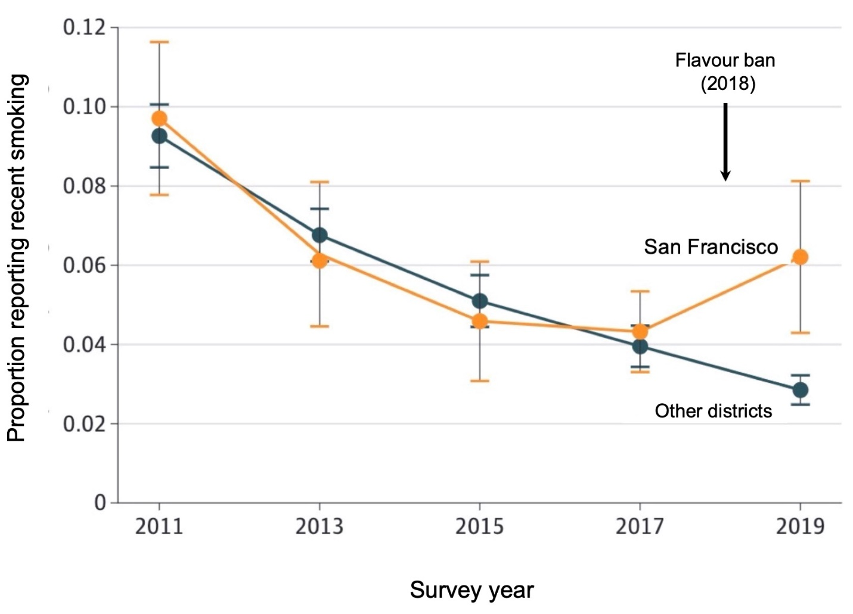
Impact of a law banning vaping flavours on youth smoking.
From Friedman (2021). Note the increase in the number of teenagers who smoked cigarettes following the implementation of the law banning flavours in 2018 (arrow).

Nova Scotia banned all flavoured vaping products on April 1st 2020 (17). This resulted in a 5.6% increase in cigarette consumption in fiscal year 2020-21 (April 1, 2020 to March 31, 2021). During the same period cigarette consumption in Ontario declined.
As a result of this ban, 24 out of 55 (44%) Nova Scotia vape shops closed immediately and only 10 expect to stay open if the ban is not overturned. (VITA “Nova Scotia Vape Shop Report”). This not only represents a loss of jobs and associated tax income, but it also deprives Nova Scotian smokers and vapers from the knowledge and experience of vape shop staff, and it makes it more difficult for them to purchase legitimate vaping products.

WHAT ARE THE ALTERNATIVES TO A FLAVOUR BAN?

- Increase enforcement of the existing laws prohibiting the supply of vaping equipment to minors. Seek out and punish both commercial and social suppliers of vape to underage people. For repeat offenders, a short term in jail may be appropriate. Make sure these arrests, prosecutions and punishments are well publicised.

- Bans on advertising to children and youth should be strongly enforced, with particular attention to social media and influencer marketing.

- Consider using public information announcements, or inserts in tobacco packages, to inform smokers of the benefits of vaping.

- Concentrate on selling vape through independent specialty adult-only vape stores rather than convenience stores and gas stations, which are more likely to sell to minors and less well-equipped to provide smoking cessation advice. Licence adult-only vape stores, with the understanding that their licence will be revoked if they sell to minors.

- Research best practices for encouraging smoking cessation in the vape shop environment. Teach the psychology of addiction, the pharmacology of nicotine, and best practices in smoking cessation to the staff. Provide a certification in smoking cessation to guide consumers to those stores which have staff qualified to help them quit.

- Continue to allow internet sales for people who cannot access vape stores due to infirmity or living in a remote location. Enforce the use of state of the art age verification systems both at the time of sale and during the delivery process.

- Develop a vape that is made to medical standards, which can be used in research, prescribed by physicians, sold in pharmacies and covered by provincial and territorial health insurance plans. This legitimises vaping, and may make it more attractive to middle aged and elderly smokers. Use of vaping by older adults, and the availability of vapes in mainstream drug stores, may make vaping less attractive to teenagers.

CONCLUSIONS

Teen vaping is a moderately important issue, but perhaps less important than other risky behaviours undertaken by young people. It may have reached a peak and be levelling off.
Teen smoking is a serious issue, because half of all tobacco smokers die prematurely from smoking-related diseases. Teenage vaping seems to be associated with a decline in teenage tobacco smoking, creating a net health benefit.
We should accept some amount of teen vaping in order to reduce teen smoking rates.
A vape flavour ban will make vape less attractive to everyone.
It is more likely to increase tobacco smoking than to decrease vaping.

References
1. David J. K. Balfour, DSc, Neal L. Benowitz, MD, Suzanne M. Colby, PhD, Dorothy K. Hatsukami, PhD, Harry A. Lando, PhD, Scott J. Leischow, PhD, Caryn Lerman, PhD, Robin J. Mermelstein, PhD, Raymond Niaura, PhD, Kenneth A. Perkins, PhD, Ovide F. Pomerleau,. Balancing Consideration of the Risks and Benefits of E-Cigarettes. [Online] https://ajph.aphapublications.org/doi/pdf/10.2105/AJPH.2021.306416.
2. Health Canada. Canada Gazette, Part I, Volume 155, Number 25: Order Amending Schedules 2 and 3 to the Tobacco and Vaping Products Act (Flavours). REGULATORY IMPACT ANALYSIS STATEMENT. [Online] https://gazette.gc.ca/rp-pr/p1/2021/2021-06-19/html/reg2-eng.html.
3. Oyston, Dr. John. Canada’s proposed vape flavour ban. [Online] https://oyston.com/blog/flavourban/.
4. Statistics Canada. Canadian Tobacco and Nicotine Survey, 2020. [Online] https://www150.statcan.gc.ca/n1/daily-quotidien/210317/dq210317b-eng.htm.
5. U.S. Food and Drug Administration. E-Cigarette Use Among Middle and High School Students — National Youth Tobacco Survey, United States, 2021. [Online] https://www.cdc.gov/mmwr/volumes/70/wr/mm7039a4.htm?s_cid=mm7039a4_w.
6. Samantha Shiplo, Christine D Czoli, David Hammond. E-cigarette use in Canada: prevalence and patterns of use in a regulated market. [Online] https://bmjopen.bmj.com/content/bmjopen/5/8/e007971.full.pdf.
7. CDC Morbidity and Mortality Weekly Reports (MMWR). Tobacco Product Use and Associated Factors Among Middle and High School Students—. [Online] https://www.cdc.gov/tobacco/data_statistics/mmwrs/byyear/2019/ss6812a1/index.html.
8. Action on Smoking and Health. Use of e-cigarettes among young people in Great Britain. [Online] https://ash.org.uk/wp-content/uploads/2021/07/Use-of-e-cigarettes-among-young-people-in-Great-Britain-2021.pdf .
9. Christopher Russell, Neil McKeganey, Tiffany Dickson & Mitchell Nides. Changing patterns of first e-cigarette flavor used and current flavors used by 20,836 adult frequent e-cigarette users in the USA. [Online] https://link.springer.com/article/10.1186/s12954-018-0238-6.
10. Farsalinos Survey Shows Vapers Prefer Fruit and Dessert Flavors. [Online] https://vaping360.com/vape-news/69440/farsalinos-survey-shows-vapers-prefer-fruit-and-dessert-flavors/.
11. Peter Hajek, Ph.D., Anna Phillips-Waller, B.Sc., Dunja Przulj, Ph.D., Francesca Pesola, Ph.D., Katie Myers Smith, D.Psych., Natalie Bisal, M.Sc., Jinshuo Li, M.Phil., Steve Parrott, M.Sc., Peter Sasieni, Ph.D., Lynne Dawkins, Ph.D., Louise Ross, Maciej Go. A Randomized Trial of E-Cigarettes versus Nicotine-Replacement Therapy. [Online] https://www.nejm.org/doi/10.1056/nejmoa1808779.
12. Cochrane Collaboration. Can electronic cigarettes help people stop smoking, and do they have any unwanted effects when used for this purpose? [Online] https://www.cochrane.org/CD010216/TOBACCO_can-electronic-cigarettes-help-people-stop-smoking-and-do-they-have-any-unwanted-effects-when-used.
13. Abigail S. Friedman, PhD and SiQing Xu. Associations of Flavored e-Cigarette Uptake With Subsequent Smoking Initiation and Cessation. [Online] https://jamanetwork.com/journals/jamanetworkopen/fullarticle/2766787.
14. Shannon Gravely, PhD, K Michael Cummings, PhD, David Hammond, PhD, Eric Lindblom, JD, Danielle M Smith, MPH, Nadia Martin, PhD, Ruth Loewen, MA, Ron Borland, PhD, Andrew Hyland, PhD, Mary E Thompson, PhD. The Association of E-cigarette Flavors With Satisfaction, Enjoyment, and Trying to Quit or Stay Abstinent From Smoking Among Regular Adult Vapers From Canada and the United States: Findings From the 2018 ITC Four Country Smoking and Vaping Survey. [Online] https://academic.oup.com/ntr/article/22/10/1831/5843872.
15. Action on Smoking and Health (ASH). Use of e-cigarettes (vapes) among adults in Great Britain. [Online] https://ash.org.uk/wp-content/uploads/2021/06/Use-of-e-cigarettes-vapes-among-adults-in-Great-Britain-2021.pdf.
16. Heather Posner, Katelyn Romm , Lisa Henriksen, Debra Bernat, , Carla J Berg. Reactions to sales restrictions on flavored vape products or all vape products among young adults in the US. [Online] https://pubmed.ncbi.nlm.nih.gov/34331447/.
17. Abigail S. Friedman, PhD. A Difference-in-Differences Analysis of Youth Smoking and a Ban on Sales of Flavored Tobacco Products in San Francisco, California. [Online] https://www.ncbi.nlm.nih.gov/pmc/articles/PMC8145156/.
18. David, Daniel. Nova Scotia’s Ban of Vaping Product Flavours, Increased Smoking. [Online] https://vitaofcanada.com/nova-scotias-ban-of-vaping-product-flavours-increased-smoking/ .

