APPLICATION FOR NORTH AMERICAN NATIVE PLANT SOCIETY GARDEN AWARD

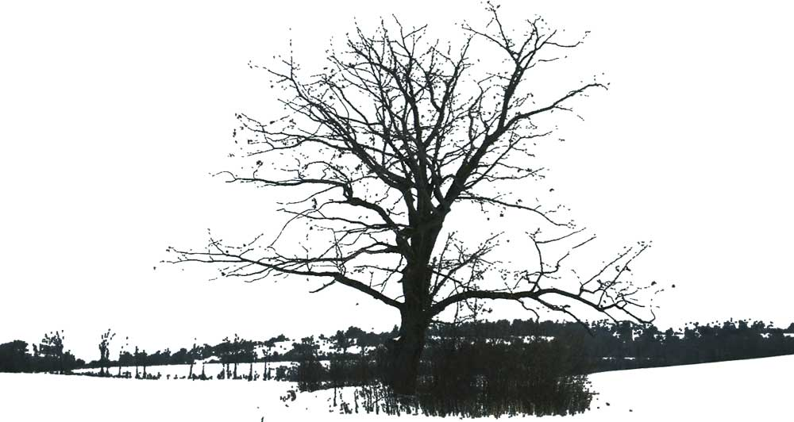

OAK HILLS FARM PRAIRIE AND ARBORETUM

Contents:

Application for North American Native Plant Society Award

Appendix 1: NANPS Checklist

Appendix 2: Suppliers

Appendix 3: Assistance, Advice and References

Appendix 4: Prairie Plant List

Appendix 5: Arboretum Tree List

Appendix 6: Illustrations

Appendix 7: Maps

OAK HILLS FARM PRAIRIE AND ARBORETUM

In 2004, my family purchased a 101 acre property between Port Hope and Peterborough, in Northumberland County, Ontario, Canada. The property is in the Oak Ridges Moraine and overlooks Rice Lake. It includes rolling farmland, wide hedgerows and 30 acres of bush. We proceeded to build a cottage and develop a large scale native plant garden on part of the property around the cottage and towards the lake.

This application refers to a four acre area which has been developed since 2007 as a re-creation of the original Rice Lake Tall Grass Prairie and as an Arboretum for local trees and plants. This area, which was a farmer’s hayfield, planted with alfalfa and timothy grass is now planted exclusively with Ontario native species.

Suitability
The commercial value of the field as a rental for agricultural use was $30 per acre. Alternative land uses, such as the growth of medicinal herbs, or planting with switchgrass or hybrid poplars for cellulosic ethanol production were considered but were not economically viable. There was no trace of prairie remnants in the field, or in the small, unfarmed strip along the east side of the field. A trial area elsewhere on the property was planted with prairie species in 2005 to test the local growing conditions and gain experience. It was slow to start, but was well established by 2007. It was therefore decided to wipe out all the existing vegetation on the four acre plot and replant it as a prairie and arboretum for native grasses, plants, shrubs and trees.

Roundup was applied to the field several times during the 2007 growing season to kill weeds before they had the opportunity to set seed. A final application of herbicide was done in the spring of 2008, followed by superficial tilling. The sowing of seeds was performed on May 18th 2008, followed by harrowing to allow the seeds to settle into the disturbed soil.

Plant Community and Habitat Diversity
The prairie component was designed to be as true as possible to the likely nature of the site before European settlement. It was planted with a mixture of grasses and forbs which are native to the specific location in Northumberland County, based on advice from a number of sources (see Appendices 3 and 4). In early summer 2008 the newly planted prairie area was mowed to reduce the amount of early season weeds, and allow the warm season grasses to grow. By the fall there were large clumps of Big Blue and Indian Grass, and many Evening Primrose and Black-Eyed Susan in bloom (see Appendix 6). In the second season, some additional native plants were added, which had been grown from seed off-site and established in four inch pots. A special effort was made to plant native lupins, which are a food source for the Karner Blue butterfly.

The arboretum, which encircles the perimeter of the site, is intended to represent all the more interesting native trees and shrubs of southern Ontario. It therefore includes several Carolinian species which are native to the extreme south-west of Ontario rather than Northumberland County. There are 95 different tree and shrub species on the site (Appendix 5).

Genetic Provenance and Ethics
All the seed for the prairie, and all the trees, originated from Ontario sources. Attempts were made to get prairie grass seeds from Northumberland County. However, some established prairie recreations in the area were originally planted with seed from Lambton County or other distant sites, so their seed would be no more local than other Ontario sources. Curators of prairie remnants such as the Alderville Black Oak Savanna required all their seed for restoration and expansion at their own site. Other sites (such as Red Cloud Cemetery) had had a poor season and did not have enough seeds. An ethical local seed collector was commissioned to collect seed, but all her sources had been depleted by less ethical seed collectors. Eventually, most of the seed had to be purchased from sources in south western Ontario.

Aesthetics
The site design was constrained by the need to allow the prairie to grow in full sun, and to permit the possibility of controlled burns to maintain the prairie. A V shaped path was created through the prairie to allow access to a viewpoint over the lake, and to allow people to walk into the middle of the tall grass and view different areas within the prairie. The path will also act as a firebreak and allow half of the prairie to be burned at one time, leaving the other half untouched to preserve wildlife habitat. The trees were planted around the edge of the prairie, except for several bur oaks which were planted in the middle to provide shade at the viewpoint. To avoid blocking the view of the lake from the cottage, the prairie edge nearest the house was used for native shrubs, with the lowest growing specimens in the centre. The arrangement of specific species was sometimes related to cultural requirements (e.g. specimens needing damp, shady conditions were placed in a low lying relatively sheltered corner). Trees of the same family (e.g. oaks, maples) were planted together where possible. In some areas, an effort was made to alternate large trees with smaller understorey trees. During planting, the trees were fertilized with transplanter fertilizer to encourage root growth and dusted with Myke to provide mycorrhizae. They were staked, mulched with wood chips and protected with a tree guard.

The project was funded by the owners. All the work (apart from the initial spraying of the site and the prairie planting) was undertaken by the owners. Northumberland Stewardship Council sold some of the trees at a reduced price. The Kenny’s from Rainbow Cottages donated their time to assist with the planting.

The reaction of neighbours was either positive or neutral. There was relief that we did not attempt develop the landscape with several cottages, a golf course or a trailer park. Most people appreciated our “no hunting” policy. Many people were unaware that the land was originally prairie and needed educating about the need to restore prairie habitat. People with an interest in local wildlife were appreciative of our efforts to create habitat for them. The site is home to several red foxes, a flock of wild turkey, some nesting ospreys and a herd of white-tailed deer.
APPENDIX 1: NANPS CHECKLIST

Location: 4945 Oak Hills Road, Bewdley, Ontario, Canada
Land entrance at GPS: N 44°05.519’ W 078° 17.674’

Closest Urban Centres: Roughly midway between Port Hope and Peterborough

Province: Ontario

Type of location: Four acres, but part of an overall 101 acre lot. The lot also includes approximately 30 acres of mixed bush (oak, poplar, white pine, sumac, grey dogwood and open areas) 65 acres of agricultural land, and a two acre house and conventional garden which also includes many native trees, wild flowers and grasses. It is situated in the Oak Ridges Moraine on a gently rolling hillside facing north towards Rice Lake.

What type of project: Prairie Re-creation and Arboretum

Is there a water source for wildlife? Rice Lake about 1 km from north end of site. Seasonal stream in adjoining bush.

Do you use …
Pesticides: Never
Herbicides: Sometimes. Glyphosate (Roundup) is used from time to time to eliminate invasive species such as dog strangling vine, poison ivy, Canada thistle, etc.
One application of 2-4 Dicamba was needed to remove resistant residual alfalfa which had formerly been grown as a crop on the site

Watering: Trees get one watering during planting. The prairie never gets watered.

Soil type(s): Mixed, mostly silty

Conditions: Sunny & Dry
APPENDIX 2: SUPPLIERS

PRAIRIE SEED SUPPLIERS:
Main supplier: Pterophylla, Walsingham, Ontario
Additional supplies from:
Acorus Restoration, Walsingham, Ontario
Emony Nicholls, Wild Ginger Nursery (Local Seed Collection)
Ontario Seed Company

ARBORETUM TREE SUPPLIERS:
Acorus Restoration, Walsingham, Ontario
Baltimore Nursery, Baltimore, Ontario
Evergreen, Don Valley Brick Works, Toronto, Ontario
Ecology Park, Peterborough, Ontario
Guelph Arboretum (Fall Plant Sale 2007, 2008)
Humber Nurseries, Brampton, Ontario
Loblaws Supermarkets, Toronto, Ontario
North American Native Plant Society (Plant Sale in Markham, May 2008, 2009)
Northumberland Stewardship Council (Glenn Mcleod)
Pterophylla, Walsingham, Ontario
Richardsons Tree Farm, Kendal, Ontario
Society of Ontario Nutgrowers' Annual Auction, Toronto, Ontario
Van Den Nest Tree Nursery, Eden, Ontario
APPENDIX 3: ASSISTANCE AND ADVICE

PLANTING ASSISTANCE:
Tony and Lukas Kenny, Rainbow Cottages (Planting and harrowing)
Allan Cole, Bewdley (Herbicide and Tilling)
Tindall Tree Services (Provided large amounts of wood chippings for mulch)

ADVICE:
Acorus Restoration, Walsingham, Ontario
Bill Newell (Resources Technician, Ganaraska Conservation, Ontario)
Ed Borczon (University of Toronto)
Ed Heuval
Emony Nicholls (Wild Ginger Native Plant Nursery, Parrytown, Ontario)
Gavin Trevelyan (Eastern Regional Co-ordinator, Tallgrass Ontario)
Graham Buck (Tallgrass Ontario)
Janine Mcleod (Alderville, Ontario)
Julie Van Den Nest (Van Den Nest Tree Nursery, Eden, Ontario)
Ken Towle (Ecologist, Kawartha Conservation, Ontario)
Norm Wagenaar (Caring for the Moraine Project, Landowner Contact Specialist)
Pterophylla, Walsingham, Ontario (Peter Carson and Mary Gartshore)
Rick Beaver (Alderville, Ontario)
Tod Farrell (Nature Conservancy)
Tom Whillans (Trent University)
Tony Kenny (Rainbow Cottages)

REFERENCE PUBLICATIONS:
Prairie:
Planting the Seed – A Guide to Establishing Prairie and Meadow Communities in Southern Ontario: Kim Delaney, Lindsay Rodger, P. Allen Woodcliffe Gail Rhynard and Paul Morris, Environment Canada
http://www.on.ec.gc.ca/wildlife/docs/doc-planting-prairie-e.html
A Landowners Guide to Tallgrass Prairie and Savanna Management in Ontario
Cathy Quinlan, Tallgrass Ontario
http://www.tallgrassontario.org/Publications/LandownersGuide2005.pdf
To Know This Place Rick Beaver, Sweetgrass Studios, Alderville First Nation
The Tallgrass Restoration Handbook for Prairies, Savannas, and Woodlands
Stephen Packard and Cornelia Mutel, Island Press 1997
Catalogues of: Ontario Seed Company, Acorus Restoration, Pterophylla and
Prairie Nursery, Wisconsin
Trees:
Trees of Ontario Linda Kershaw, Lone Pine 2001
Trees in Canada John Laird Farrar, Fitzhenry & Whiteside Ltd 1999
Shrubs of Ontario James Soper and Margaret Heimburger, Royal Ontario Museum 1982
Recommended List of Trees and Shrubs for University of Waterloo Plantings
R. Suffling, P. Eagles and L. Lamb, July 1997.

